Truck Platooning System

Namık Mert Tunçbilek  
*Embedded Systems Engineering  
Fachhochschule Dortmund*Dortmund, Germany  
line 5: email address or ORCID

Veli Ateş  
*Embedded Systems Engineering  
Fachhochschule Dortmund*Dortmund, Germany  
line 5: email address or ORCID Nijat Dashdamirov  
*Embedded Systems Engineering  
Fachhochschule Dortmund*Dortmund, Germany  
line 5: email address or ORCID

Vignesh Arumugam  
*Embedded Systems Engineering  
Fachhochschule Dortmund*Dortmund, Germany  
line 5: email address or ORCID Mirudhubashini Ramasamy Sridharan  
*Embedded Systems Engineering  
Fachhochschule Dortmund*Dortmund, Germany  
mirudhubashini.ramasamysridharan002@stud.fh-dortmund.de

*Abstract*—Truck Platooning is the future of transportation in which trucks drive agreeably at less than 1 moment separated made possible by automated driving innovation. Transportation companies’ advantage from lower fuel utilization and enhancements in (driver) efficiency, whereas society benefits from less mishaps, more secure activity and less congested streets, and lower carbon outflows.

Keywords—Platooning, mechanized driving, lower carbon

# Introduction

Transportation is vital to society and economy, and street cargo transportation accounts for about 60% of all surface cargo transportation. The request for street cargo transport is anticipated to extend within the coming a long time. As appeared within the American Trucking Association’s 2015 report, the trucking industry comprises about 80% of a 1.33 trillion-dollar shipping and coordination’s industry within the US. In any case, bounty of fuel utilization and nursery gas outflow have been created. For case, street transport speaks to around 27% of the vitality utilization of the European Union. Furthermore, indicated that vehicles account for 20% of the entire carbon emanation of which a quarter comes from overwhelming obligation vehicles (HDVs). Subsequently, the natural impacts amid the method of transport got to be diminished direly. In expansion, the fetched of fuel has an expansive share of add up to transportation costs. Fuel fetched spoken to about 30% of the life cycle taken a toll of owning and working a truck. Additionally, agreeing to the American Transportation Investigate Institute’s (ATRI) later report, fuel is respected as the moment biggest taken a toll, where the most elevated is faculty cost. With a huge sum of HDVs and the expanding request for street cargo, it can be anticipated that indeed small advances in fuel efficiency can decipher into significant taken a toll diminishment [1]. And it is additionally advantageous to realize the objective of natural assurance due to less deplete gas. As a result, it is of awesome advantage to move forward fuel economy, and how to decrease fuel utilization amid traveling has turned into a prevalent theme in later a long time. Luckily, the improvements of shrewdly transportation frameworks (ITSs) have empowered strategies to improve the vitality productivity of transportation systems. A promising approach to managing with that issue is to decrease the crevice between vehicles on the street, which is ordinarily called truck companies. Truck companies, moreover known as caravans, are a set of vehicles shaping a street prepare by traveling closely in single record to encounter diminished discuss drag. This may altogether diminish fuel utilization since around one-fourth of the fuel utilization is important to streamlined drag. As a result, fuel economy can be progressed and natural invitingness can be accomplished due to less nursery gas emanation in a unit. Separated from fuel reserve funds, truck units can to contribute to an increment of street capacity and can ease activity blockage by a littler hole between vehicles. In later a long time, with the advancement of independent driving innovation, vehicles are prepared with a few sensors that empower them to watch their environment and choose in genuine time what activity ought to be taken, which are called “autonomous vehicles” or “driverless vehicles.” Driverless vehicles are able to arrange their way when driving, and they can travel in a company with littler interims to diminish fuel utilization [2]. Moreover, when driving naturally in a company, it is conceivable to diminish the hazard of rear-end collisions and to move forward activity security. With incredible points of interest said over, vehicle companies have pulled in the consideration from numerous governments and inquire about teach. As a result, a few ventures related to companies were proposed. The primary thinks about on truck computerization were “Chauffeur” inside the EU venture T-TAP from the mid-1990s to the starting of 2000. Amid the extend, Cap and Fritz conducted an explore with two trucks coupled by an “Electronic Tow Bar” to measure the fuel reserve funds. A while later, the California Way program begun it inquire about on heavy truck platooning. Within the Way program, all vehicles were completely mechanized, counting the pioneer. For case, in 2004, the program performed a fuel utilization test with two pair trucks connected by an electronic control framework for diverse spaces.

# Ease of Use

## Automated Driving Techonology

Computerized Driving innovation offers the plausibility of in a general sense changing transportation. The objective of innovation is to create vehicles drive independently in a secure and comfortably way. Preparing cars and large goods vehicles with this innovation will likely diminish mischances, fuel utilization, contamination, and blockage Many frameworks that are portion of innovation are as of now commercially accessible, such as Versatile Voyage Control (ACC), Lane Keeping Help (LKA), Independent Crisis Braking (AEB) and Mechanized Stopping or stopping help platooning builds upon these innovations, by creating the Agreeable Versatile Voyage Control (CACC). The SAE Universal Levels of Robotization for On-road Vehicles records 5 levels from no robotization to full mechanization, where truck unit can be set from levels 2 to 4 [3]. In common, Advertisement innovation are mechanical frameworks that ‘sense’ the environment employing a combination of sensors, such as lidar, radar, and cameras. The sensors can make up for each other’s shortcomings and give repetition. For occasion, on the off chance that it is greatly foggy on the street, cameras are essentially futile. However, radar and lidar still work and compensate for the need of data given by the camera. For localisation, a mechanized vehicle can utilize worldwide situating frameworks (GPS) and inertial route frameworks (INS) [4]. Once more, in the event that GPS comes up short briefly, INS can take over utilizing accelerometers (movement sensors) and spinners (turn sensors), making a difference the vehicle to orientate until GPS comes back online. This is often a really likely situation when driving in tunnels where GPS does not work, but the car is still able to orientate itself utilizing INS. [5] For remote communication, a particular Wi-Fi standard has been endorsed.

## Characteristics of the Application Domain

Reactive systems is a system in which the ECU continuously check with the voltage data for output failures [open & short circuit] triggered by external environment and temperature readings for burnt failures. Real-time systems comes under Hard-real time. Continuous/discrete/hybrid systems has discrete character in time. Values of output voltage & temperature readings are acquired in a discrete manner in a pre-defined time. Dependable systems address reliability attribute by having certain number of life cycles or warranty periods. Availability is required, since this is needed to ensure its functions availability as soon as BCM[Body Control Module] gets powered up and need to exists till the power gets down. Also this system have Safety standard ASIL “Automotive Safety Integrity Level” which highly tells the safety functions to avoid accidents or failures.

# Model selection

The analysis of the model has taken place an important role in order to design the required model. The tasks are divided into four to complete the objectives.

## Requirement Diagram

## Used Case

## Activity Diagram

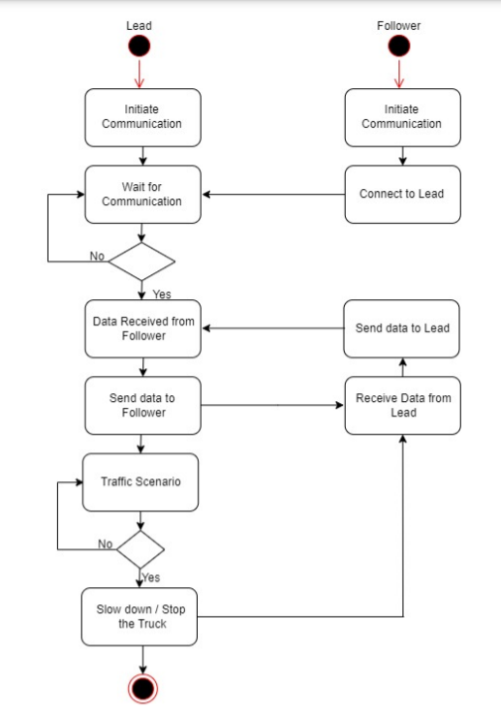

Figure 1: Activity Diagram of Truck Platooning

## Sequence Diagram

# Implementation Section

To be Filled.

# Conclusion

To be filled

##### Acknowledgment

##### We sincerely thank all the members who supported us throughout the journey of this paper and for all the contributions they have made on this paper. We appreciate for their continuous guidance and cooperation.

##### References

1. Ellwanger S, Wohlfarth E. Truck platooning application. In2017 IEEE Intelligent Vehicles Symposium (IV) 2017 Jun 11 (pp. 966-971). IEEE.J. Clerk Maxwell, A Treatise on Electricity and Magnetism, 3rd ed., vol. 2. Oxford: Clarendon, 1892, pp.68–73.
2. Calvert SC, Schakel WJ, van Arem B. Evaluation and modelling of the traffic flow effects of truck platooning. Transportation research part C: emerging technologies. 2019 Aug 1;105:1-22.K. Elissa, “Title of paper if known,” unpublished.
3. Saeednia M, Menendez M. Analysis of strategies for truck platooning: Hybrid strategy. Transportation Research Record. 2016;2547(1):41-8.
4. Janssen GR, Zwijnenberg J, Blankers IJ, de Kruijff JS. Truck platooning: Driving the future of transportation.
5. Zhang L, Chen F, Ma X, Pan X. Fuel economy in truck platooning: a literature overview and directions for future research. Journal of Advanced Transportation. 2020 Jan 3;2020.